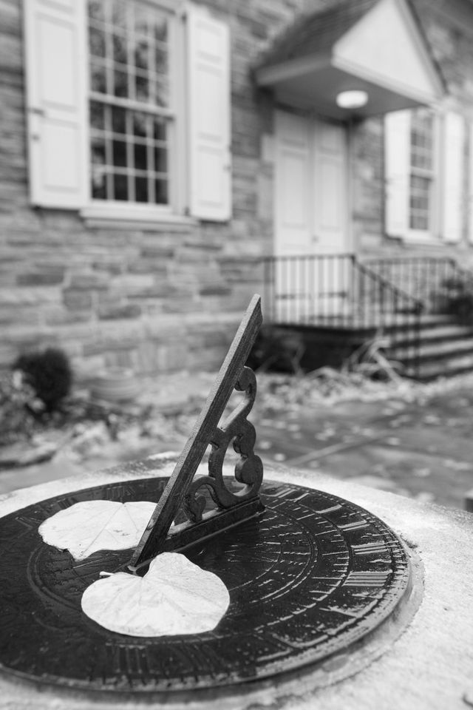
Words for Newcomers on What to do in
Meeting for Worship

“The Society of Friends has never issued specific instructions regarding what the worshiper should do during the silence, believing that such instruction would limit the freedom of the Spirit which, like the wind, ‘bloweth where it listeth.’ Sufficient for many is the admonition so often heard in Quaker meetings: ‘Heed the intimations within’. The way of true worship can eventually be found, though it may sometimes require devout and patient search….

The following spiritual exercises are among the possibilities that may present themselves:

- Self-examination: This important exercise is placed first because it may be the means by which the worshiper discovers the obstacles to a deeper communion with God. An obstacle may be a selfish or degrading desire, or merely a mind too busy with routine affairs. As awareness of human limitation progresses, less is seen with human eyes and more with the eyes of God. The inner vision is thereby enlarged to include not only oneself, but surrounding worshipers and others through wider and wider reaches in the world outside.

- Repeating to oneself a passage from the Bible or some devotional poem or other words, and reflecting on their meaning. Here there must be an effort to come into that Spirit out of which the words came, for only in the Light of that Spirit can the words have life and power.
- Reviewing in imagination some event in one’s own life, in history, or in the life of Christ, with reflection upon its significance.

- Prayer with words that have been learned.

- Prayer with one’s own words and thoughts, including confession and thanksgiving. Such prayers are not merely petitions. They are more like communion with a friend or lover when inmost desire is exposed in the light of another presence. As prayer gains in power and inwardness it becomes more and more simplified until it culminates in that which overtops all the complexities of thought.

- Prayer without words, an upsurge of feeling and will toward God. Such prayer cannot remain long in a condition of striving. It should pass over into quiet waiting and obedience. Activity is replaced by expectant possibility in which there may arise a sense of God’s nearness. As that sense increases, one feels one’s own will drawn into harmony with a Greater Will.

Such exercises of self-examination, memory, imagination, and prayer are not to be sharply distinguished from one another because the whole person may very well be present in all of them. On a given occasion, they may or may not fit the condition of the worshiper. The seeker’s path does not lie over a well-marked road, for in worship the person is on the frontier of his or her conscious being. Such explicit exercises belong primarily in the area of our upward tending toward God rather than in the realm of God’s reach toward us, though there is a sense in which we cannot seek for God without, in some degree, having already found God.”

Excerpted from Howard H. Brinton, Guide to Quaker Practice, 1943. Pendle Hill pamphlet #20

FMW Ministry & Worship Committee, June 2010

